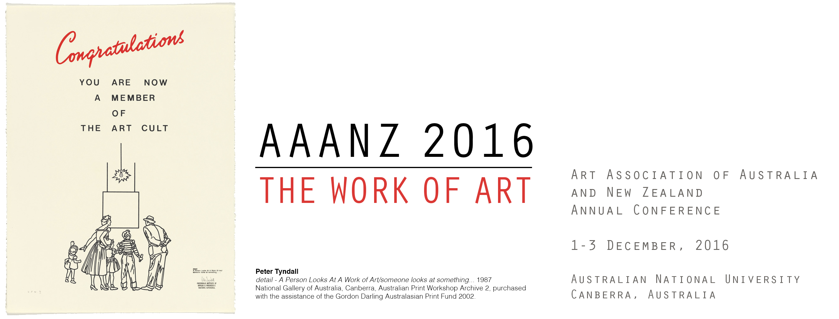
Postgraduate Student Bursary Application Form
Paper title
Session title
Abstract

Your name and contact details:
Title
Full Name
Address for Correspondence

City/ State/Region/
Country / Postcode
Degree and Institution
Current Affiliation
AAANZ Member #
Email
Telephone/Mobile
By completing and signing this form you are agreeing that you are eligible to be considered for one of 10 student bursaries for the 2016 AAANZ conference. Applications will be considered and awarded by a panel at the SOA, ANU and awarded applicants will be notified after the AAANZ conference program has been finalised. You acknowledge that the decisions of the panel will be final and no appeals to that decision will be entered into.
Signature | Date

