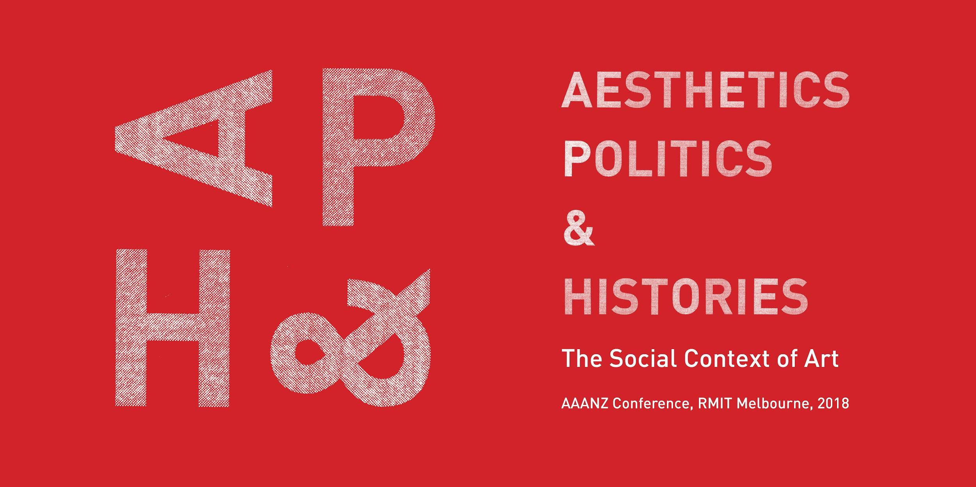

AAANZ Conference 2018

PARTICIPATION PROPOSAL FORM

Please complete and email this form to the Convenor of your selected session by Monday 3 September 2018. Convenor contact details are included with the session abstract in the call for papers. Session Convenors will notify applicants of the outcome of their proposal by Friday 7 September 2018.

Alternatively, if you would like to submit a proposal for an Open Session, please email this form to the Conference Committee, conf@aaanz.info.

PLEASE REVIEW THE SUBMISSION GUIDELINES BEFORE SUBMITTING THIS FORM
http://aaanz.info/aaanz-home/conferences/2018-conference/

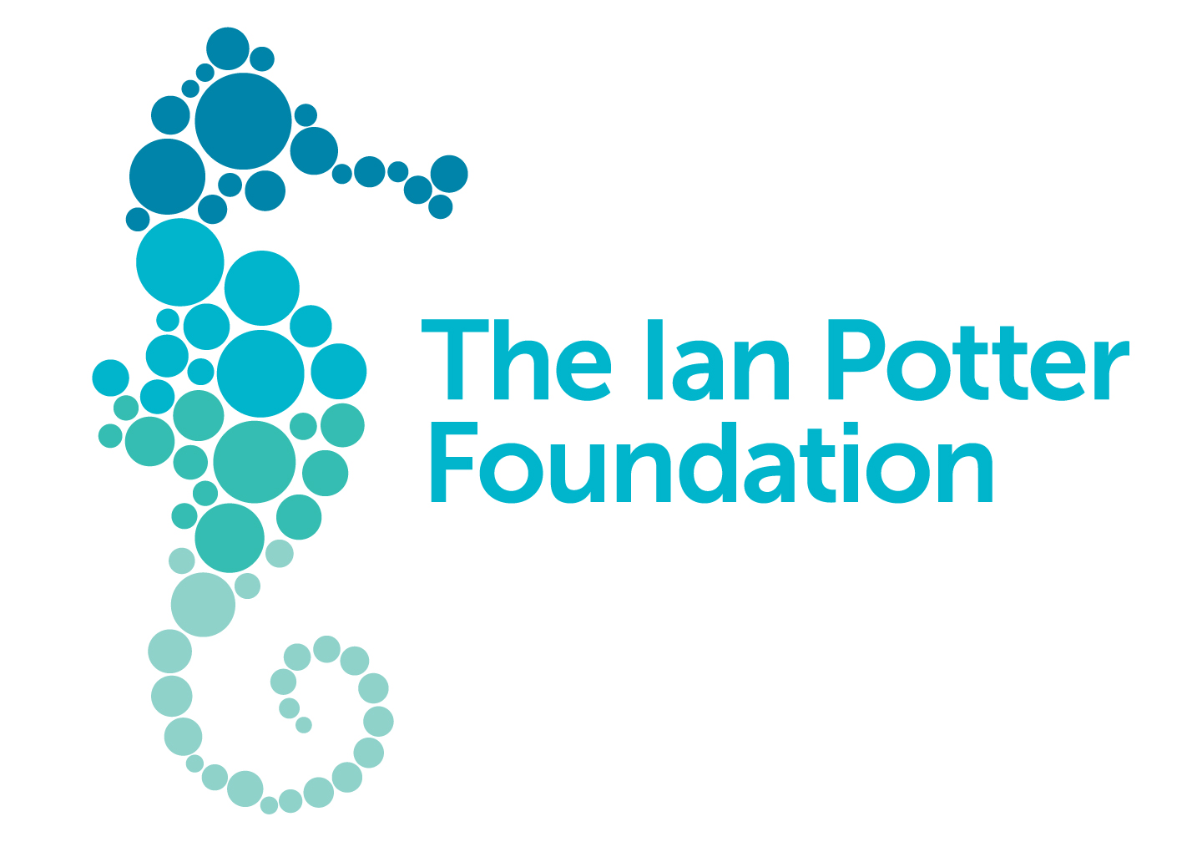
The AAANZ Conference 2018 is supported by RMIT School of Art, RMIT University’s Design & Creative Practice Enabling Capability Platform (DCP ECP), International Visiting Fellowship the Contemporary Art and Social Transformation (CAST) research group, and the Ian Potter Foundation.

Your name and details

Full name:

Institutional Affiliation:

Address:

Email:

Phone/Mobile:

Are you a member of AAANZ? YES? NO?

Speaker abstract details

Session Title:

Paper Title:

Abstract (maximum 250 words):

Bio (maximum 200 words):

Technical and space requirements (for artist session proposals only):

