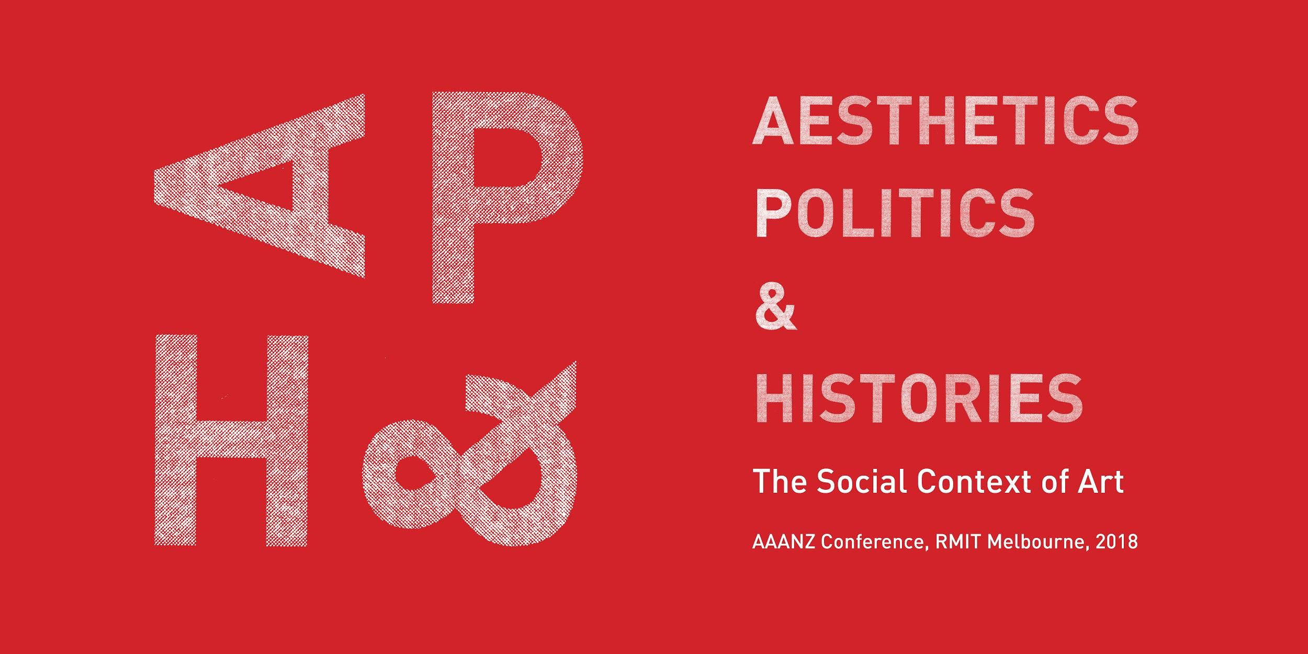

AAANZ Conference 2018

PRESENTERS AGREEMENT

By completing and signing this form you are agreeing to present at the 2018 AAANZ Conference:

Paper and panel session details
Paper Title:

Panel session Title:

Convenor(s):

Your name and contact details
Full name:

Address:

Email:

Phone/Mobile:

Your AAANZ membership details
All presenters at the AAANZ conference are required to have a current AAANZ membership. To join or renew visit: http://aaanz.info/membership/

AAANZ Membership number:

I agree to present a 20 minute paper or artist session at the AAANZ Conference to be held at the RMIT University, 5-8 December 2018. I understand that I am making a commitment to attend the conference and to pay the appropriate registration and AAANZ membership fees.

Date:

Signature:

The AAANZ Conference 2018 is supported by RMIT School of Art, RMIT University’s Design & Creative Practice Enabling Capability Platform (DCP ECP), International Visiting Fellowship the Contemporary Art and Social Transformation (CAST) research group, and the Ian Potter Foundation.

