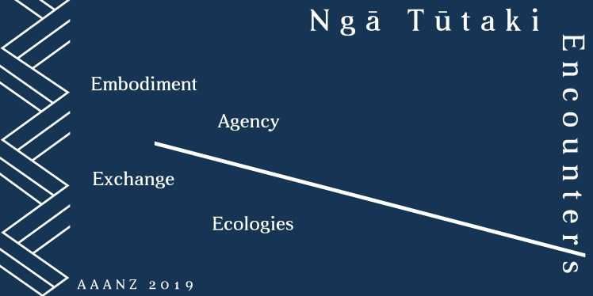
NGĀ TŪTAKI – ENCOUNTER/S:
AGENCY, EMBODIMENT, EXCHANGE, ECOLOGIES
AAANZ Conference, Auckland, 3 – 6 December 2019

Postgraduate and Early Career Researchers MASTERCLASSES
Tuesday 3 December, 2.30pm

EXPRESSION OF INTEREST due 27 September 2019
email to: conf@aaanz.info

Applications are invited from postgraduate students and early career researchers.
We aim to confirm successful applications in early October.

First name:
Family name:
Email:
University/institution:
Current/most recent degree:
Date of completion:
Research area:
Select the Masterclass you are applying for:
(these run concurrently select only ONE)
Geoffrey Batchen, Histories of the Negative
Jill Burke, Beauty Embodied: The Visual Arts and Cosmetic Culture in Renaissance Europe
Maura Reilly, Notes on Curatorial Activism
Please indicate if you are attending:
Masterclass and conference (included in conference fee)
Masterclass ONLY – attendance fee $15
Postgraduates or early career researchers whose current research engages with the theme of their selected masterclass are invited to present a short (5min) presentation. Please give a brief (200 words) summary below. Five attendees per masterclass will be selected to present.

