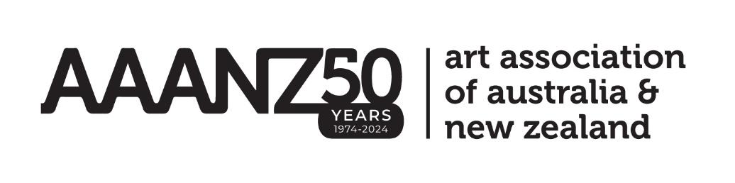

**ANNUAL GENERAL MEETING AGENDA**

**4.15 pm AEST, Thursday 5 December 2024**

Australian National University, Coombs Theatre, HC Coombs Building

1. Acknowledgement of Country
2. Apologies
3. Present
4. Acceptance of 2023 AGM Minutes
5. President’s Report
6. Treasurer’s Report
7. Journal Report
8. Business Manager’s Report
9. Declaration election/appointment to positions on Executive Committee

* President
* Australian Capital Territory Representative
* New South Wales Representative
* Queensland Representative
* South Australian Representative
* Tasmanian Representative
* Victorian Representative
* Western Australian Representative
* Indigenous Australian Representative
* Student Representative
* Advocacy Representative

11. Other Business